NCERT 2021-22 [Page 202-204]

Nodule Formation

Nodule formation involves a sequence of multiple interactions between Rhizobium and roots of the host plant. Principal stages in the nodule formation are summarised as follows: Rhizobia multiply and colonise the surroundings of roots and get attached to epidermal and root hair cells. The root-hairs curl and the bacteria invade the root-hair. An infection thread is produced carrying the bacteria into the cortex of the root, where they initiate the nodule formation in the cortex of the root. Then the bacteria are released from the thread into the cells which leads to the differentiation of specialised nitrogen fixing cells. The nodule thus formed, establishes a direct vascular connection with the host for exchange of nutrients. These events are depicted in Figure 12.4. The nodule contains all the necessary biochemical components, such as the enzyme nitrogenase and leghaemoglobin. The enzyme nitrogenase is a Mo-Fe protein and catalyses the conversion of atmospheric nitrogen to ammonia, (Figure 12.5) the first stable product of nitrogen fixation.

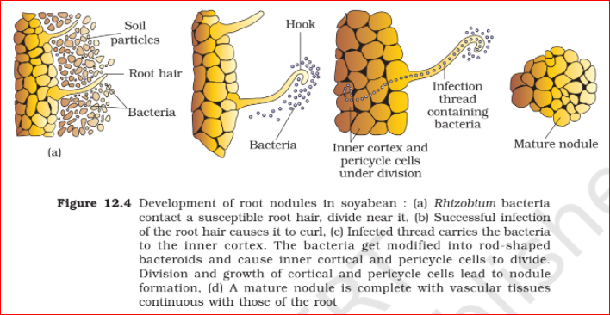

The reaction is as follows:



The enzyme nitrogenase is highly sensitive to the molecular oxygen; it requires anaerobic conditions. The nodules have adaptations that ensure that the enzyme is protected from oxygen. To protect these enzymes, the nodule contains an oxygen scavenger called leg-haemoglobin. It is interesting to note that these microbes live as aerobes under free-living conditions (where nitrogenase is not operational), but during nitrogen-fixing events, they become anaerobic (thus protecting the nitrogenase enzyme). You must have noticed in the above reaction that the ammonia synthesis by nitrogenease requires a very high input of energy (8 ATP for each NH3 produced). The energy required, thus, is obtained from the respiration of the host cells.

